# 1. Print just this page.

You don’t need the other pages, save your paper.

ragmask v2.2b1

[ragmask.com](http://ragmask.com)

# 2. Check the scale.

Make sure it printed at the right size. A real ruler should match the ruler below.

0 in

1

2

3

4

5

6

0 cm

1

2

3

4

5

6

7

8

9

10

11

12

13

14

15

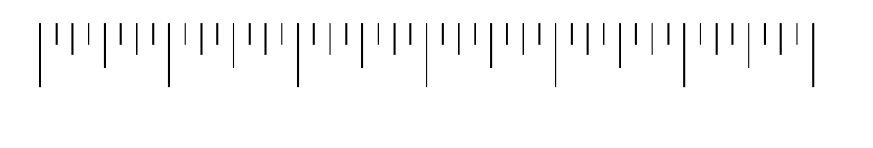

✂︎

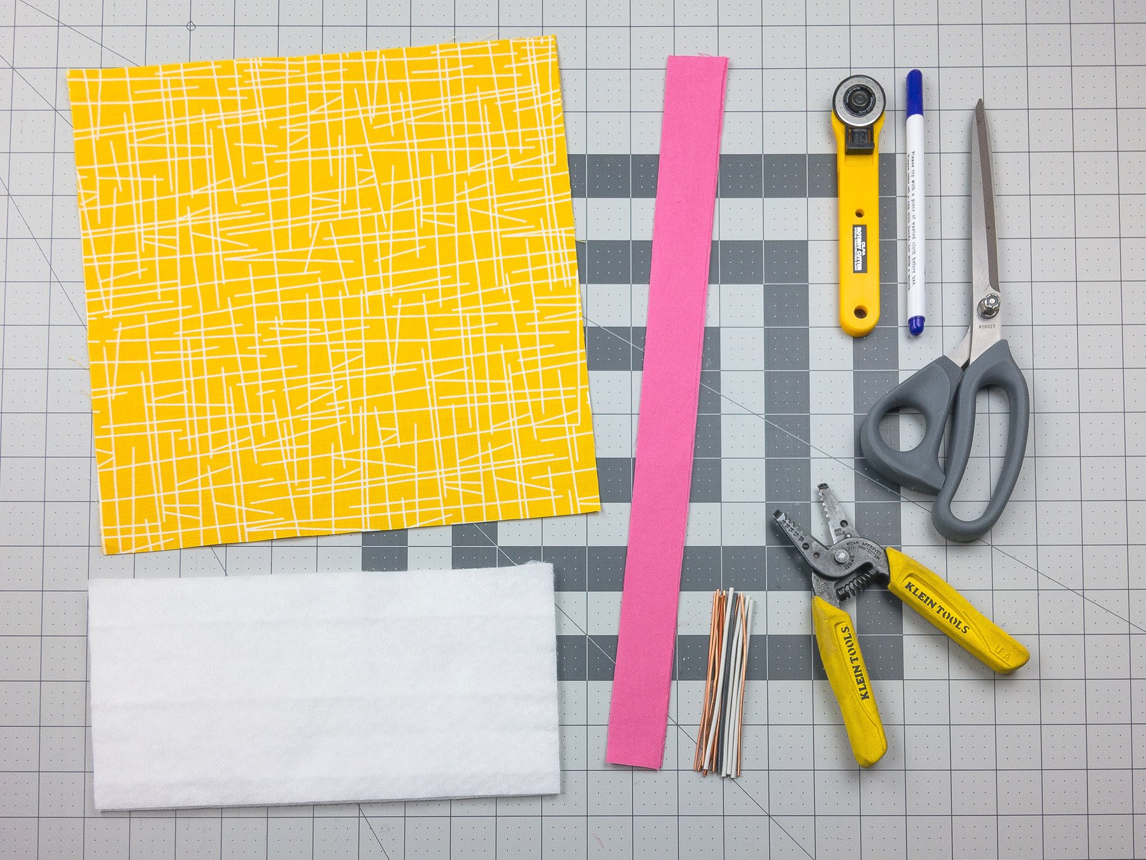

# 3. Cut materials.

11”x11” *(28x28cm)* fabric, 1 piece per mask

1”x16” *(2.5x40cm)* fabric for straps, 4 pieces per mask

10”x5” *(26x13cm)* filter (optional)*, 1 piece per mask

4” *(10cm)* metal wire, 1 piece per mask, 14ga copper wire works well

* *Effectiveness of various filter materials forthcoming.*

*See* [ragmask.com/materials](http://ragmask.com/materials) *for latest info.*

*Even no filter (just fabric) can be more effective than no mask at all.*

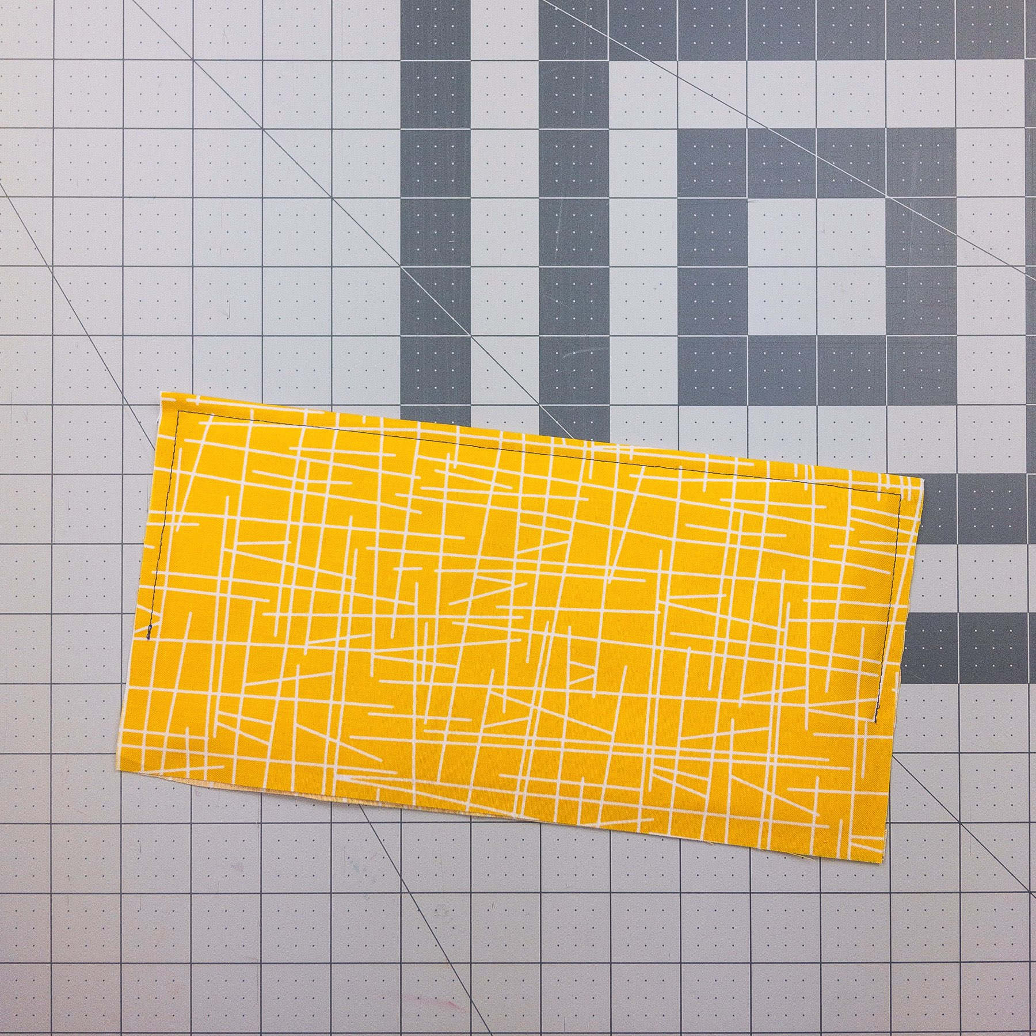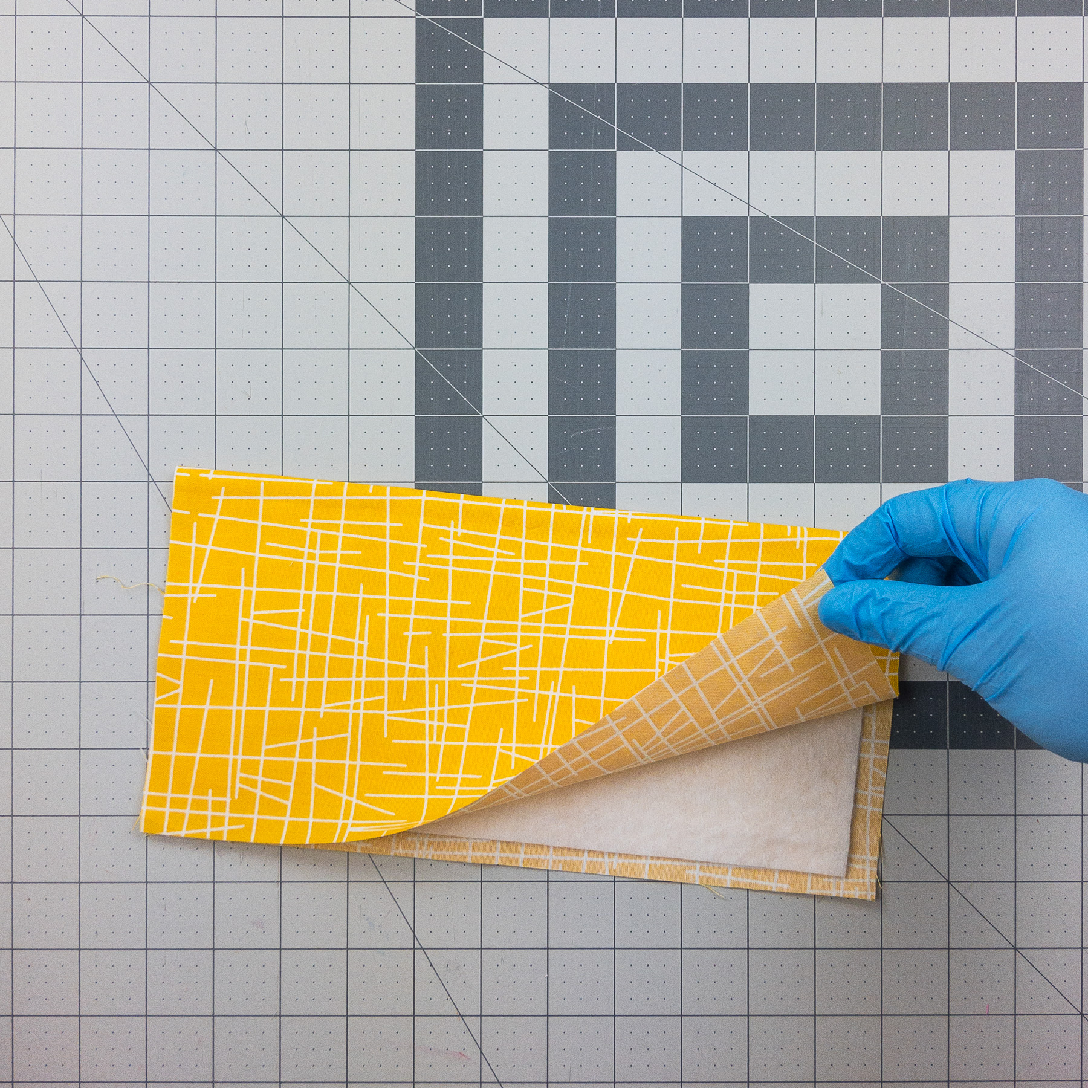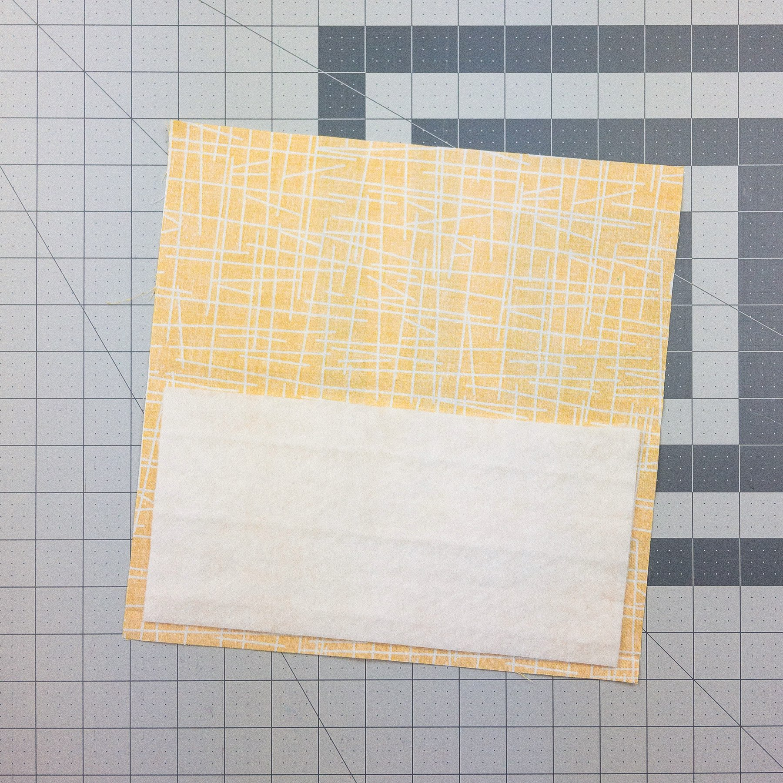

5. Sew around 3 sides.

*~3/16” (0.5cm) seam allowance, quick > pretty.*

4. Fold fabric over filter.

*2” (5cm)*

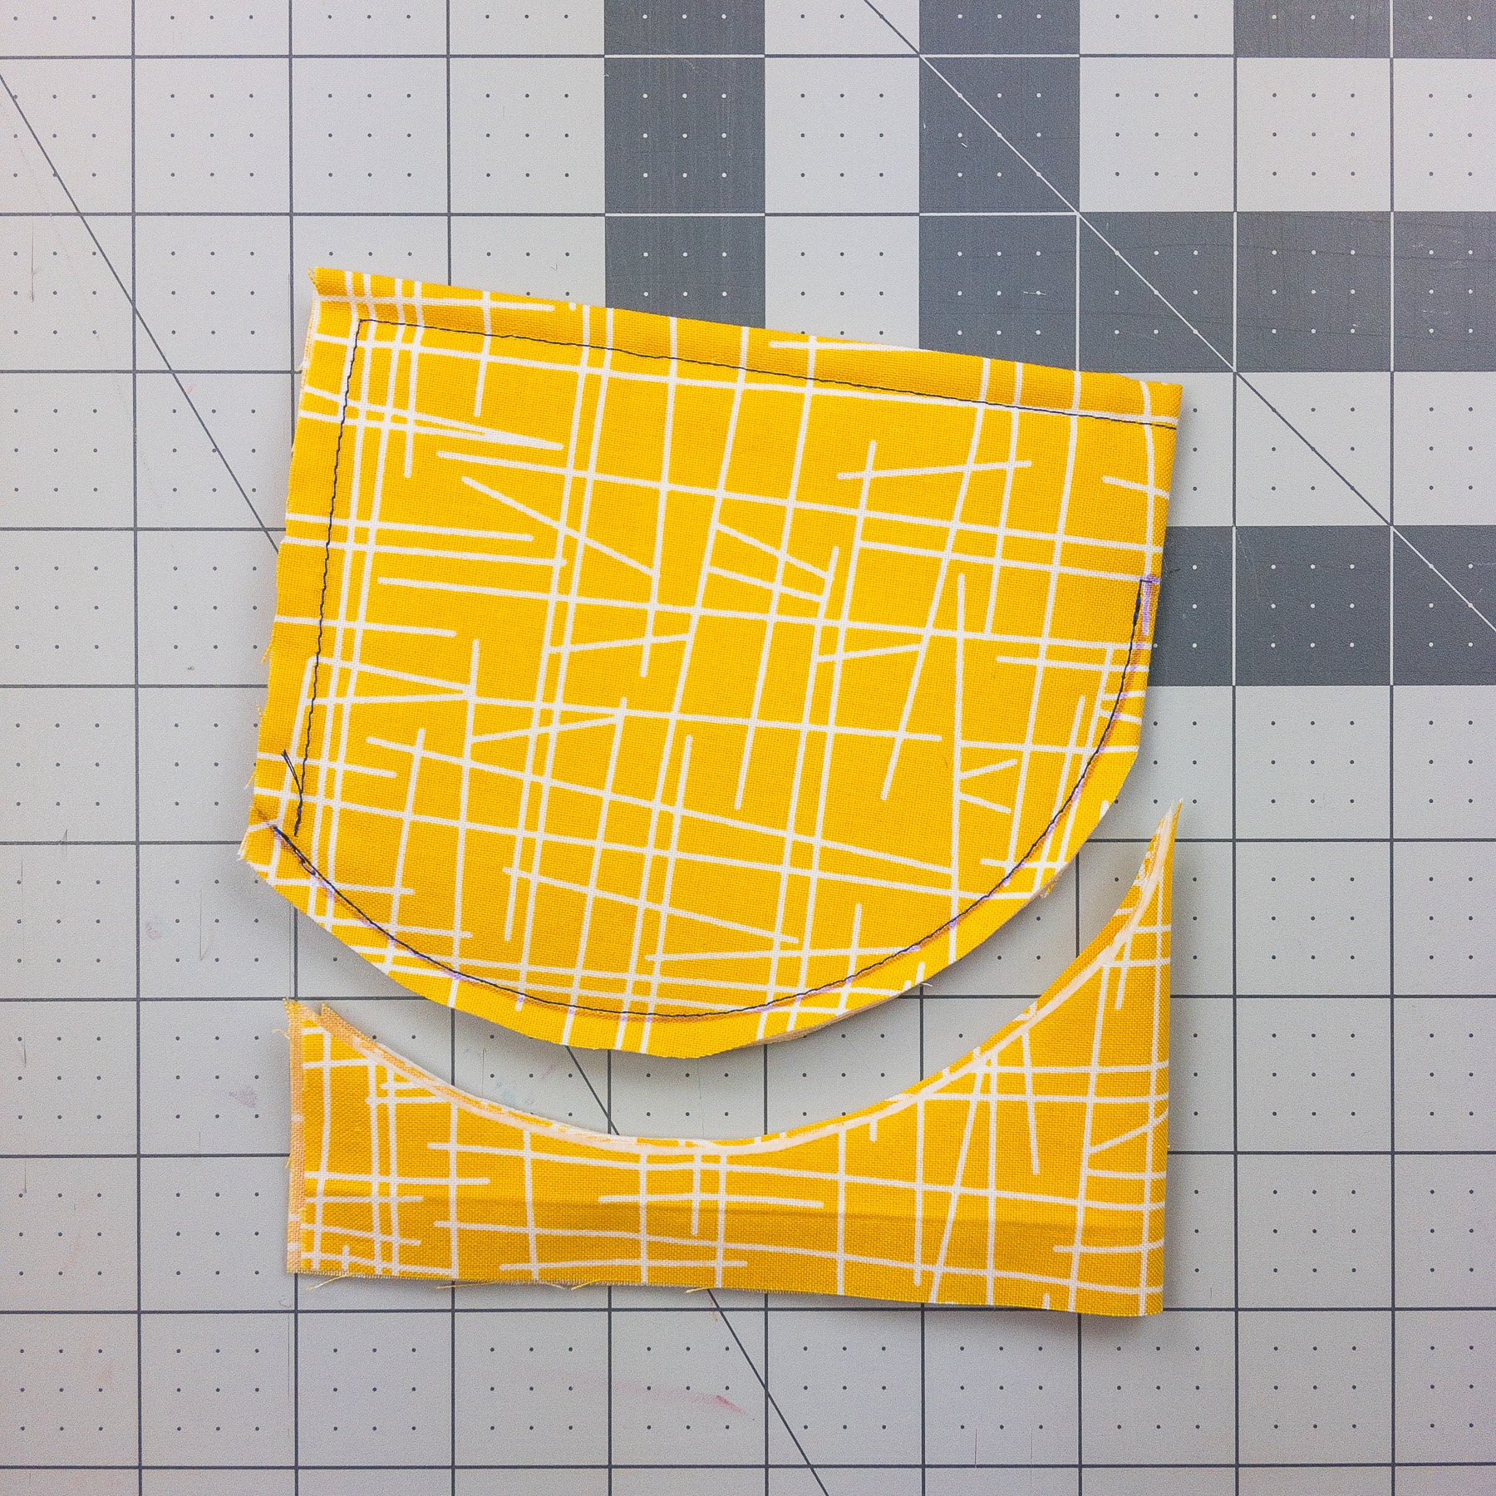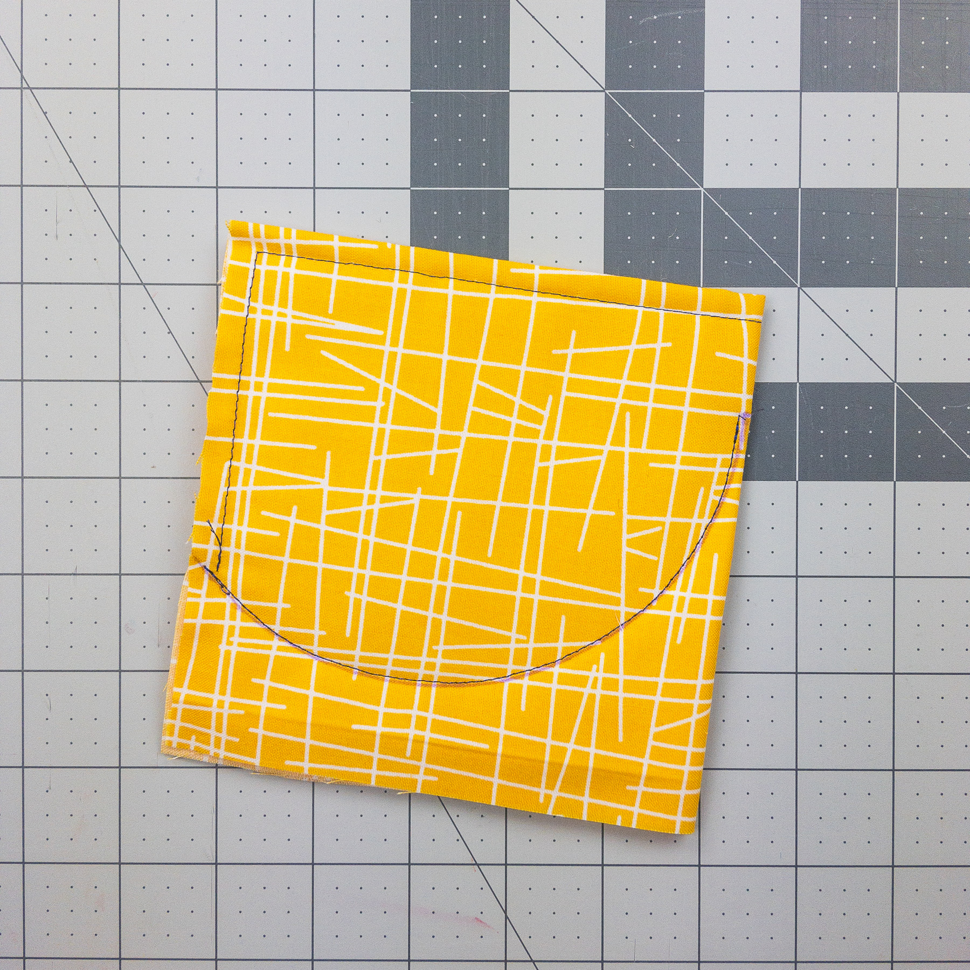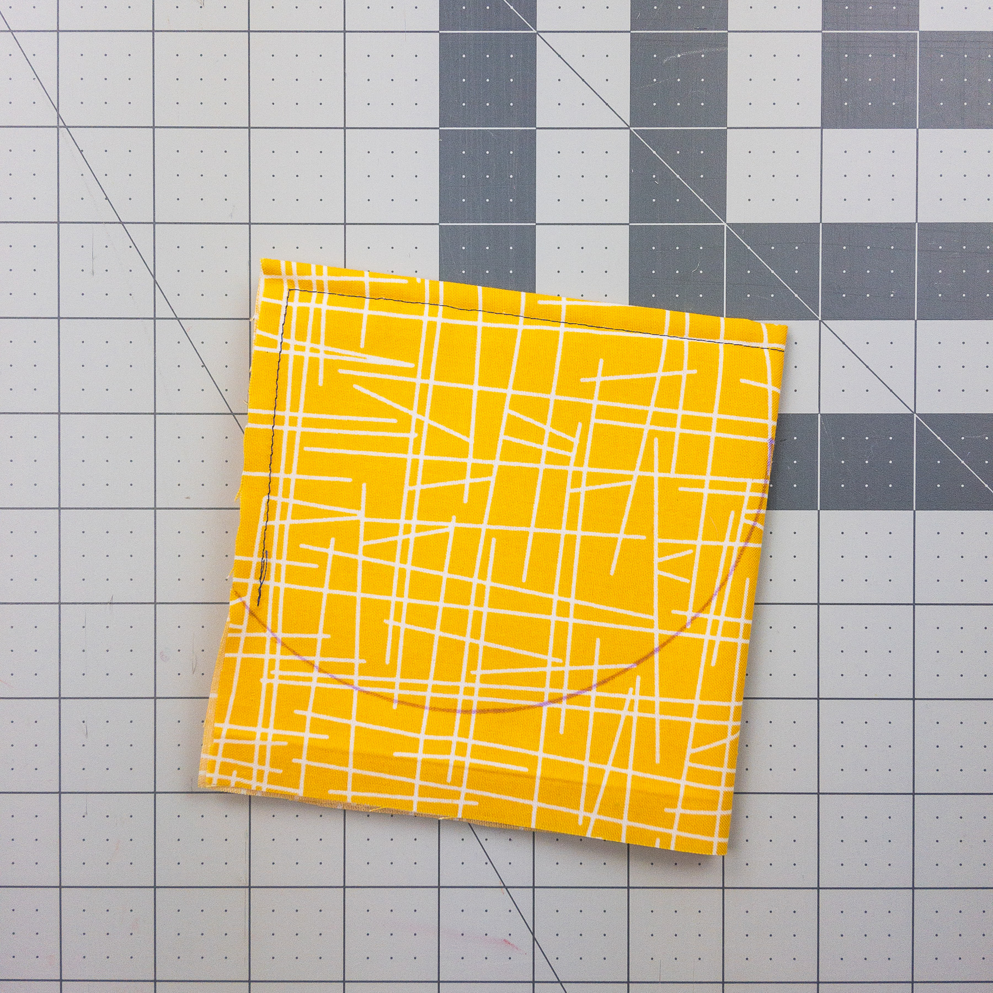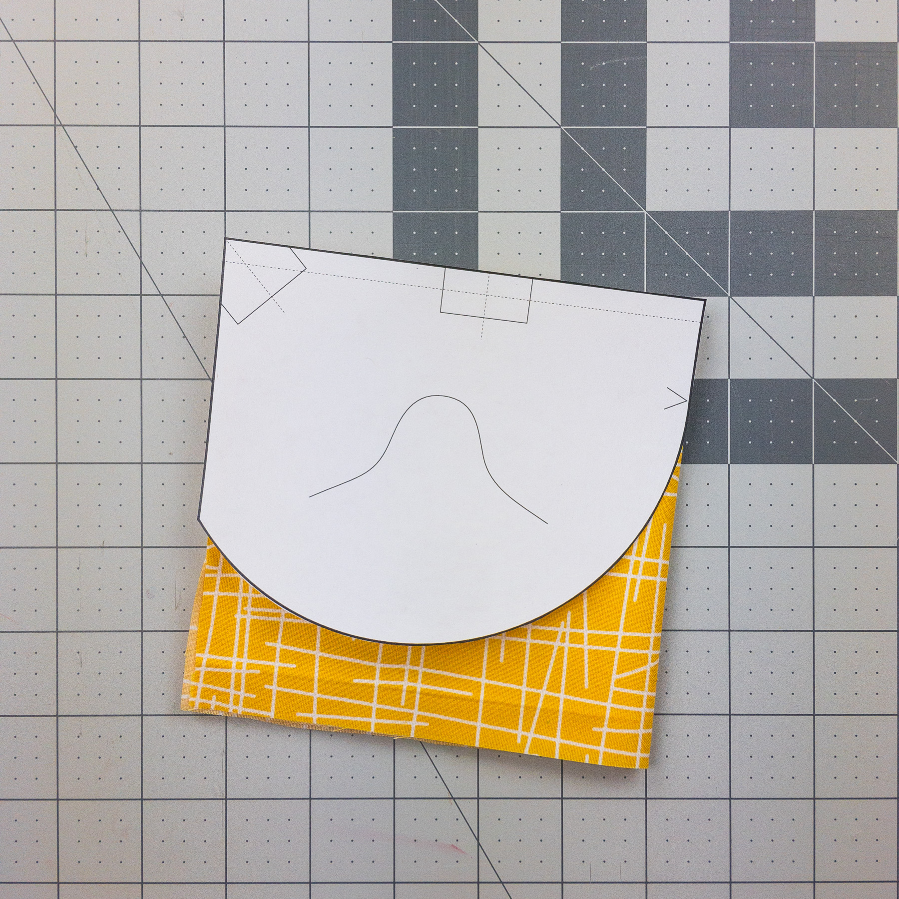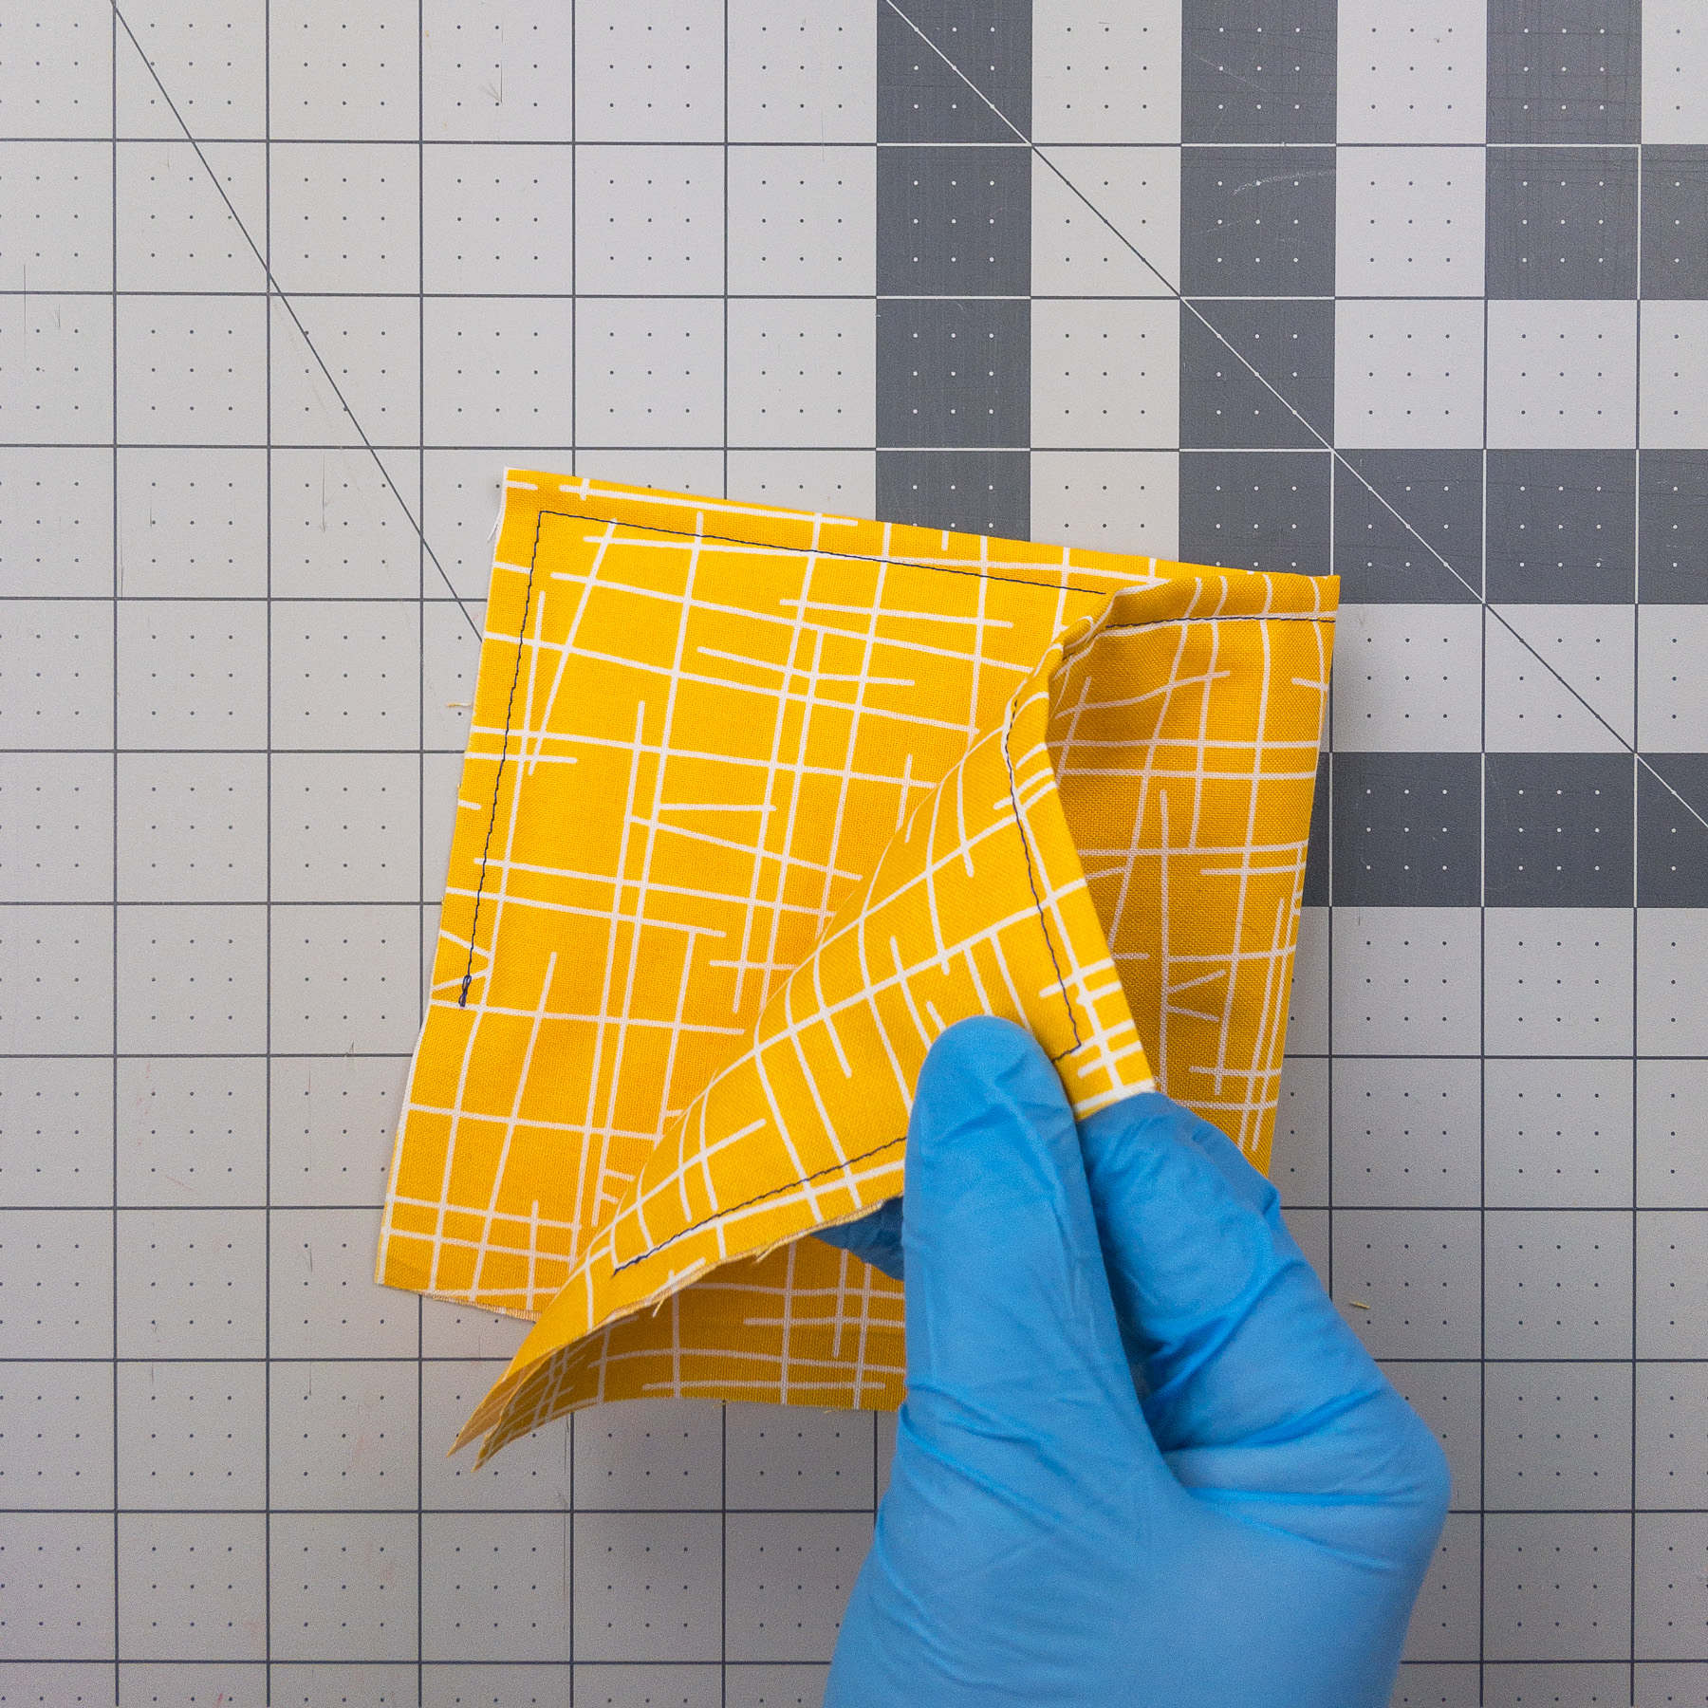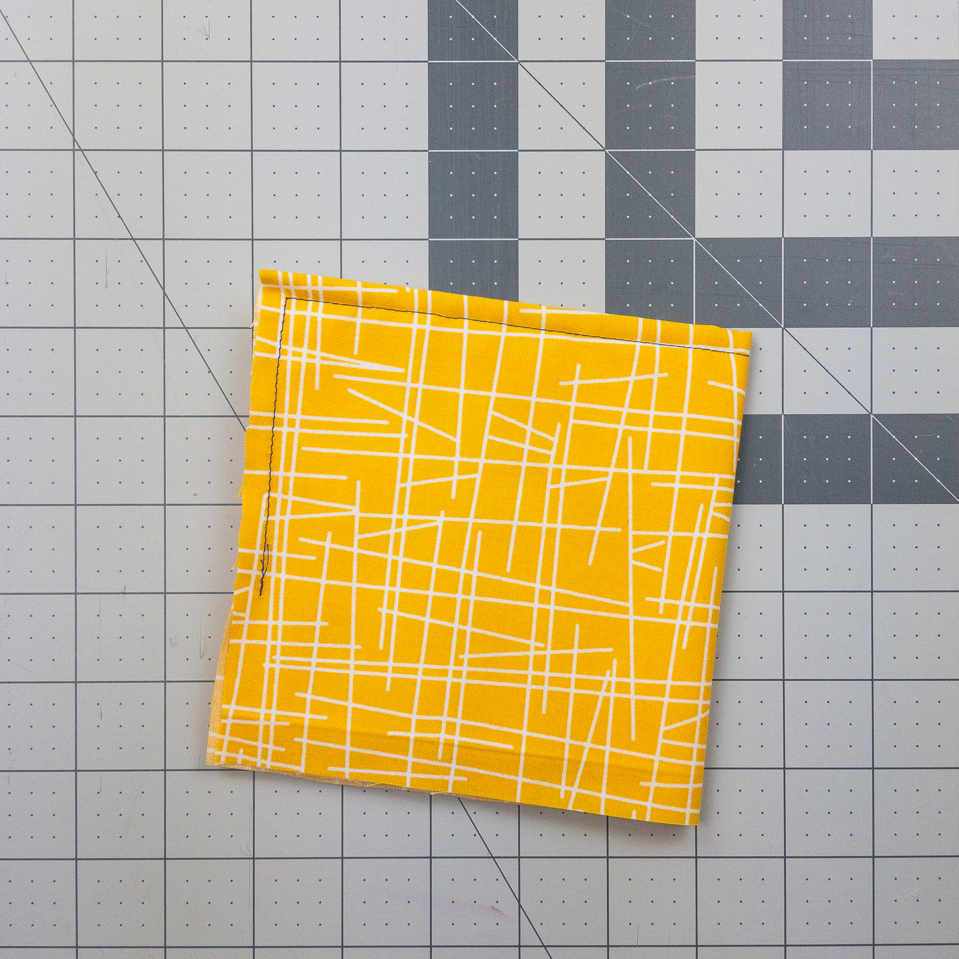

6. Fold.

7. Mark.

8. Sew.

9. Cut.

start here

*Use template from page 1.*

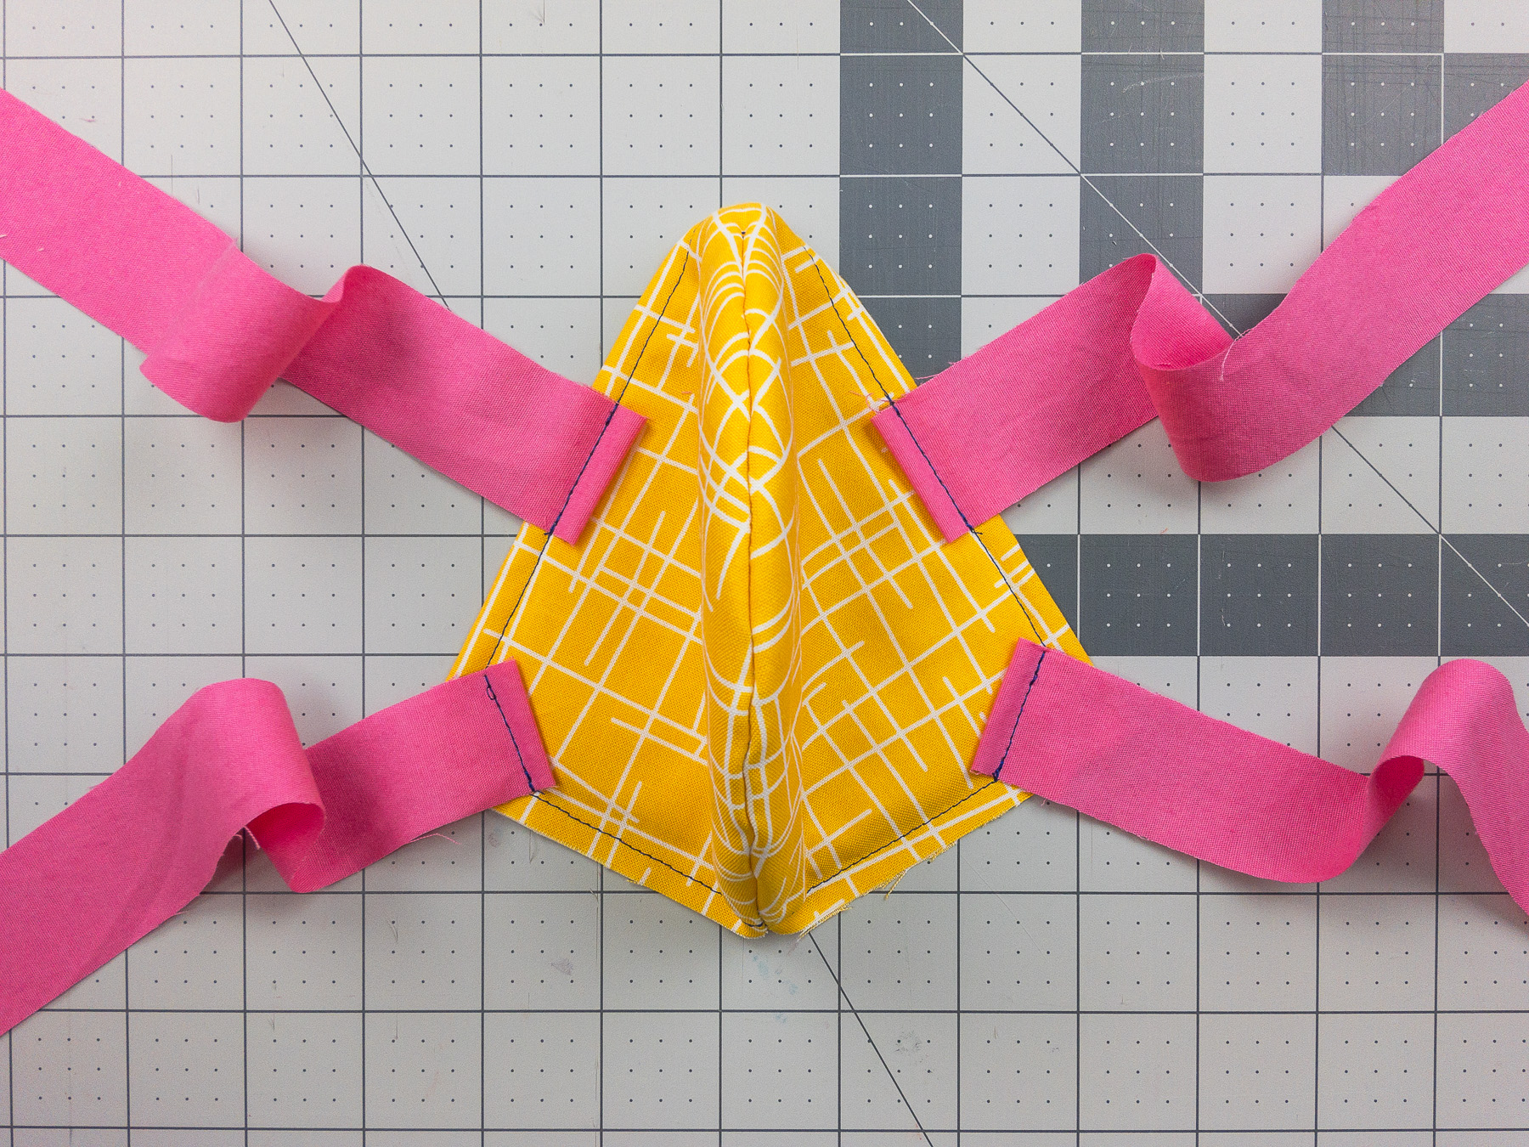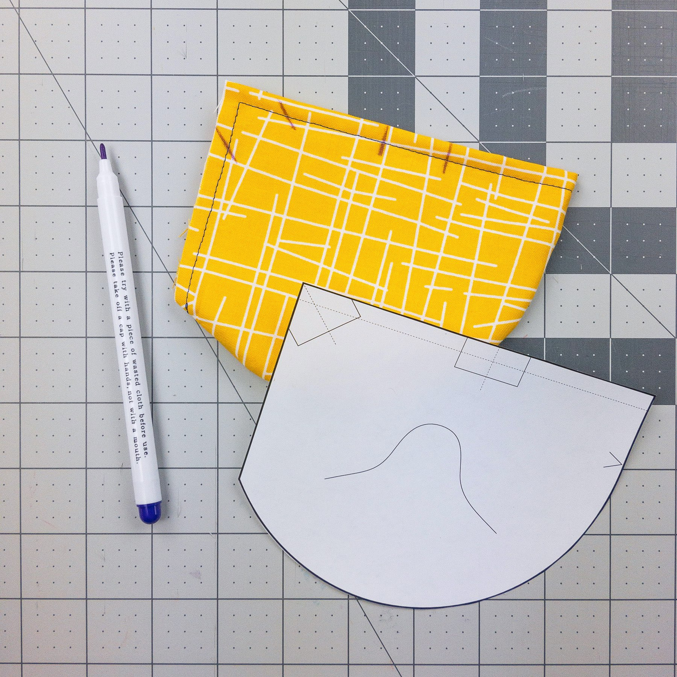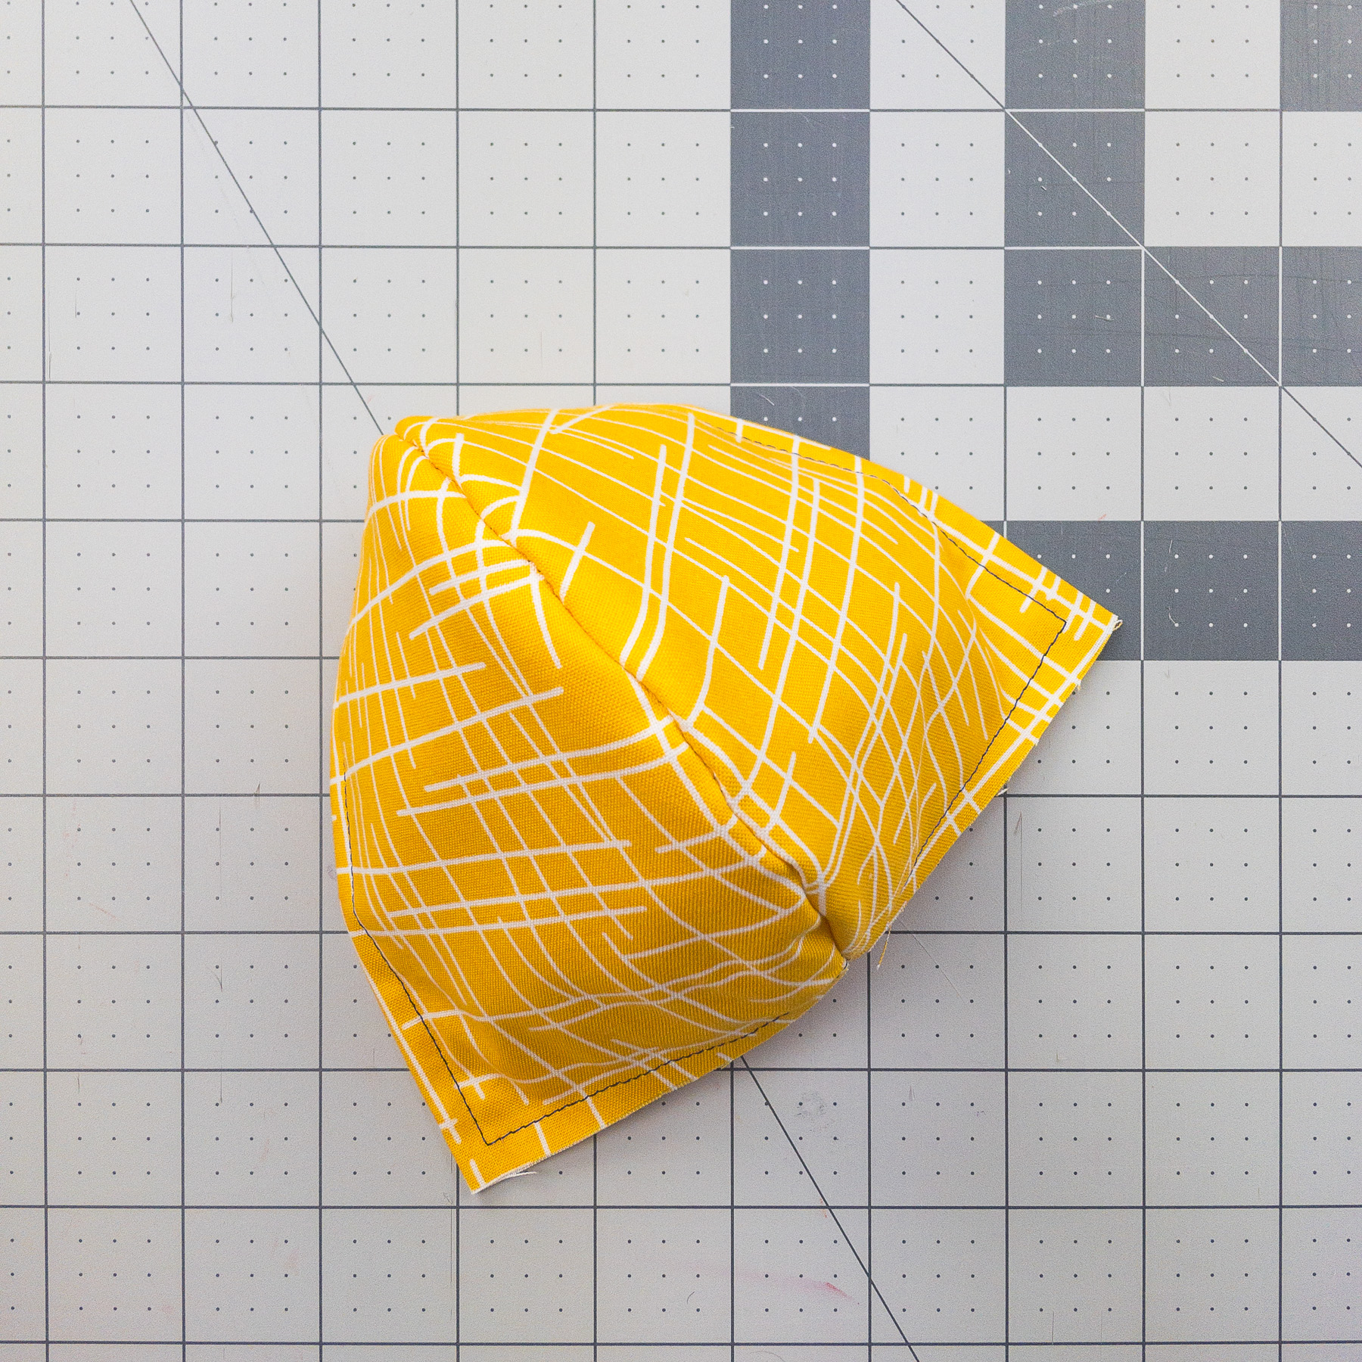

10. Flip inside out.

11. Mark strap locations.

12. Sew straps on outside face of mask.

*See last page for an even faster way to install straps.*

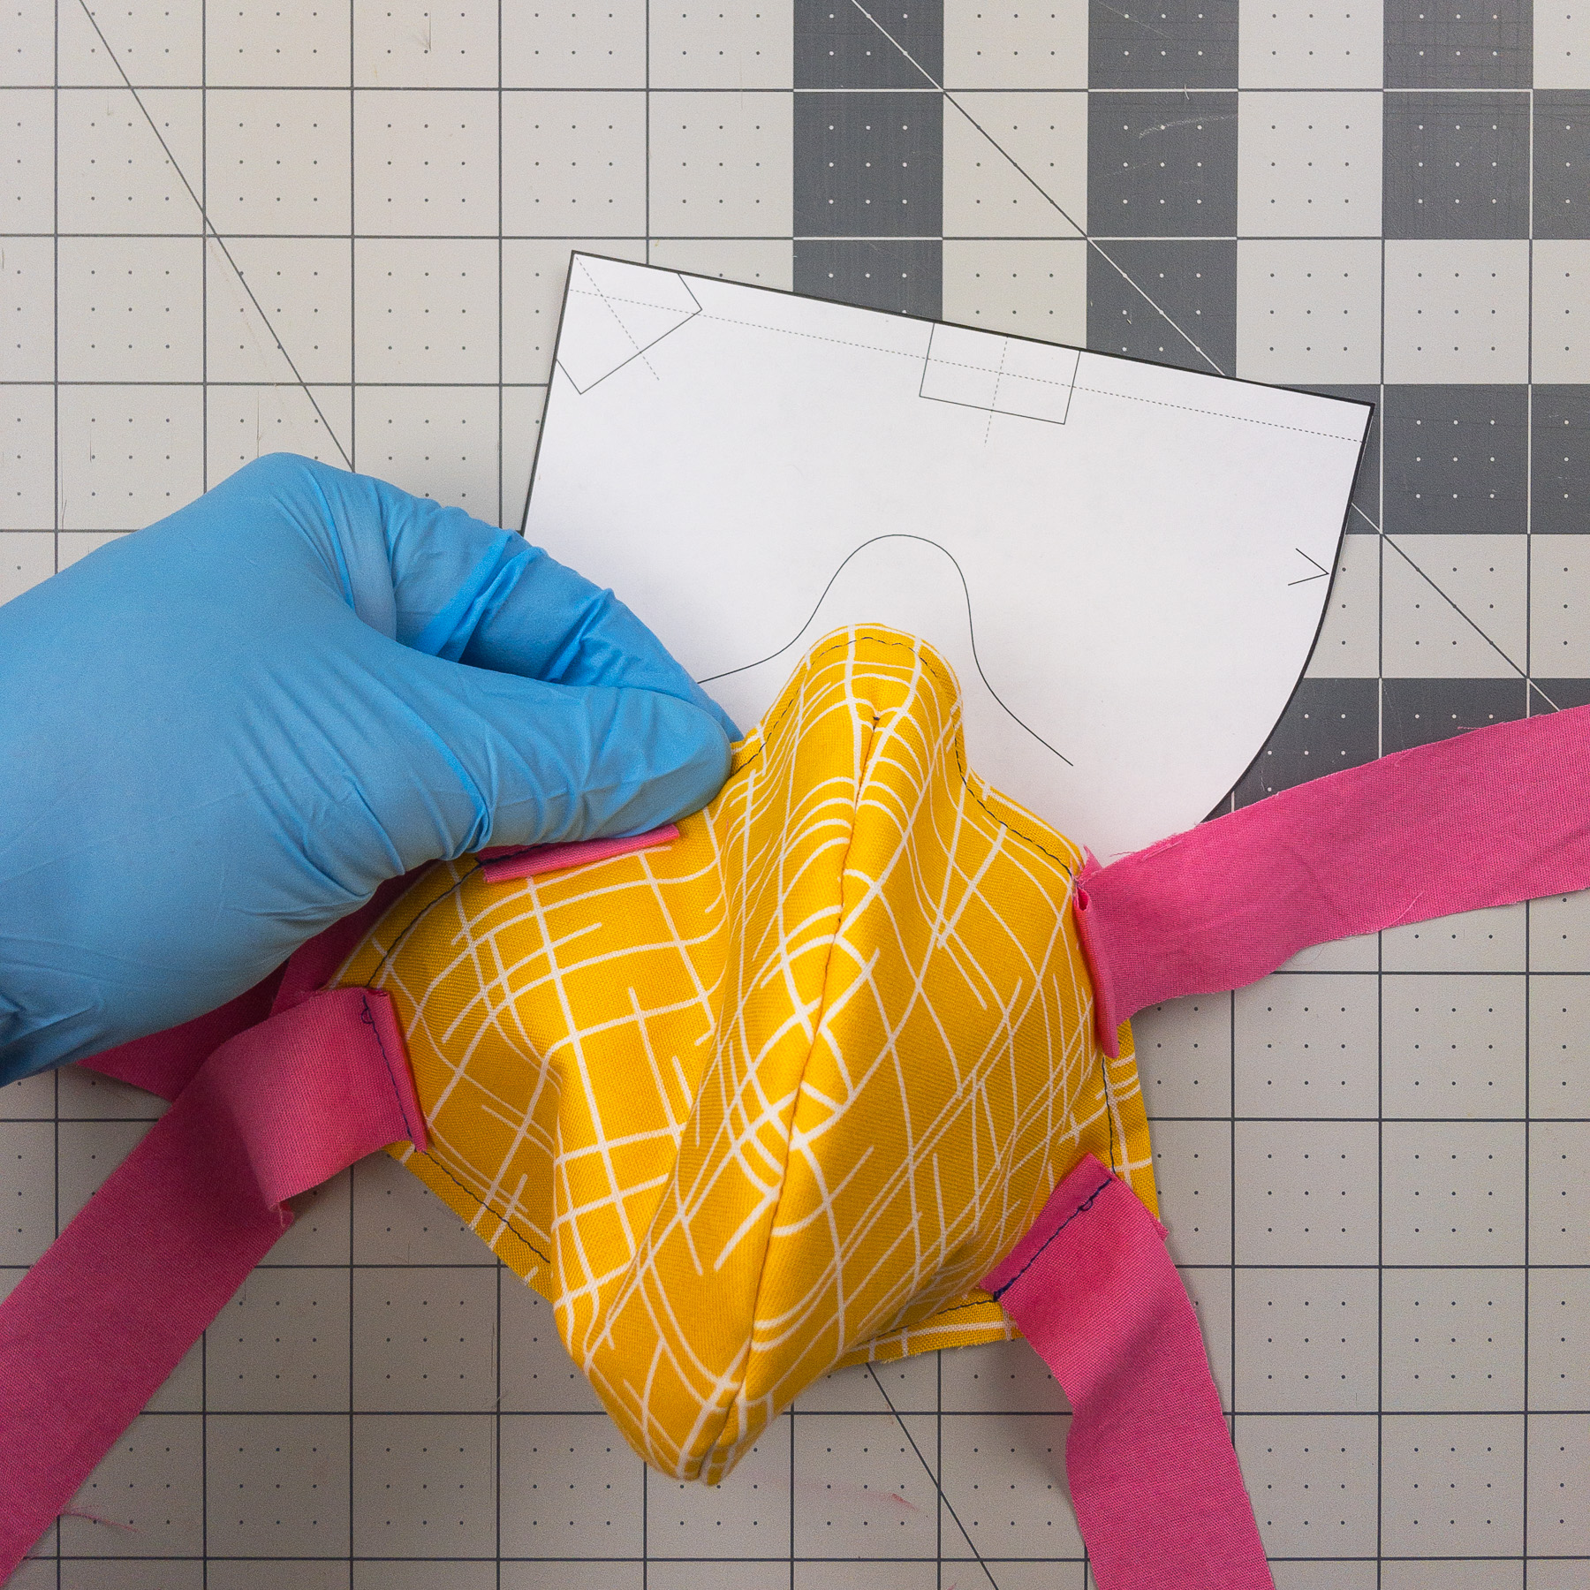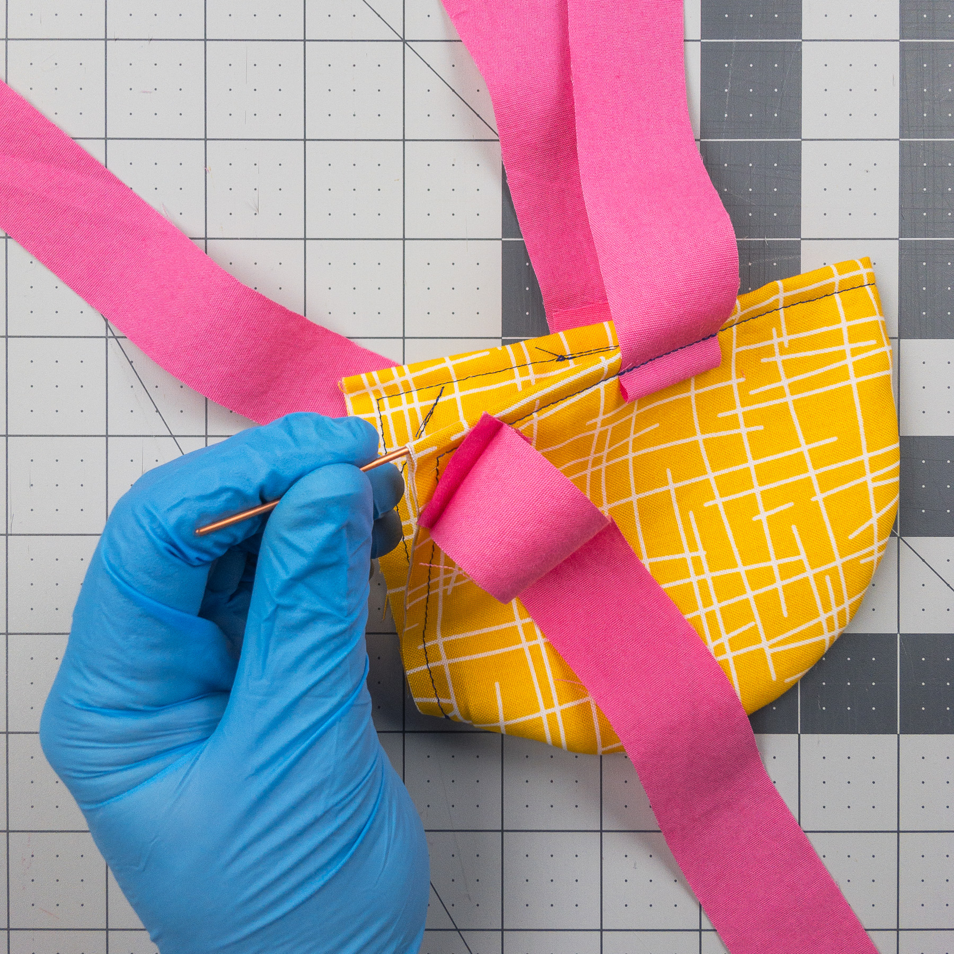

13. Insert wire and center over nose.

14. Form wire into approximate nose shape.

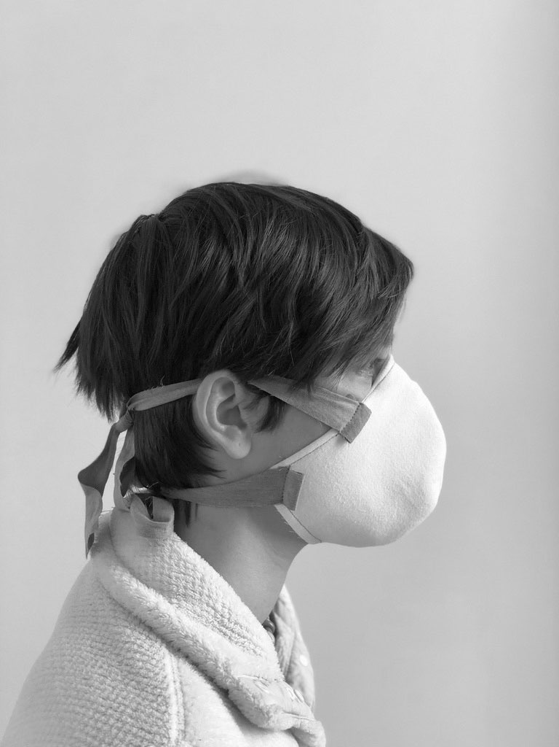

Wear

[ragmask.com](http://ragmask.com)

Use and care details forthcoming…

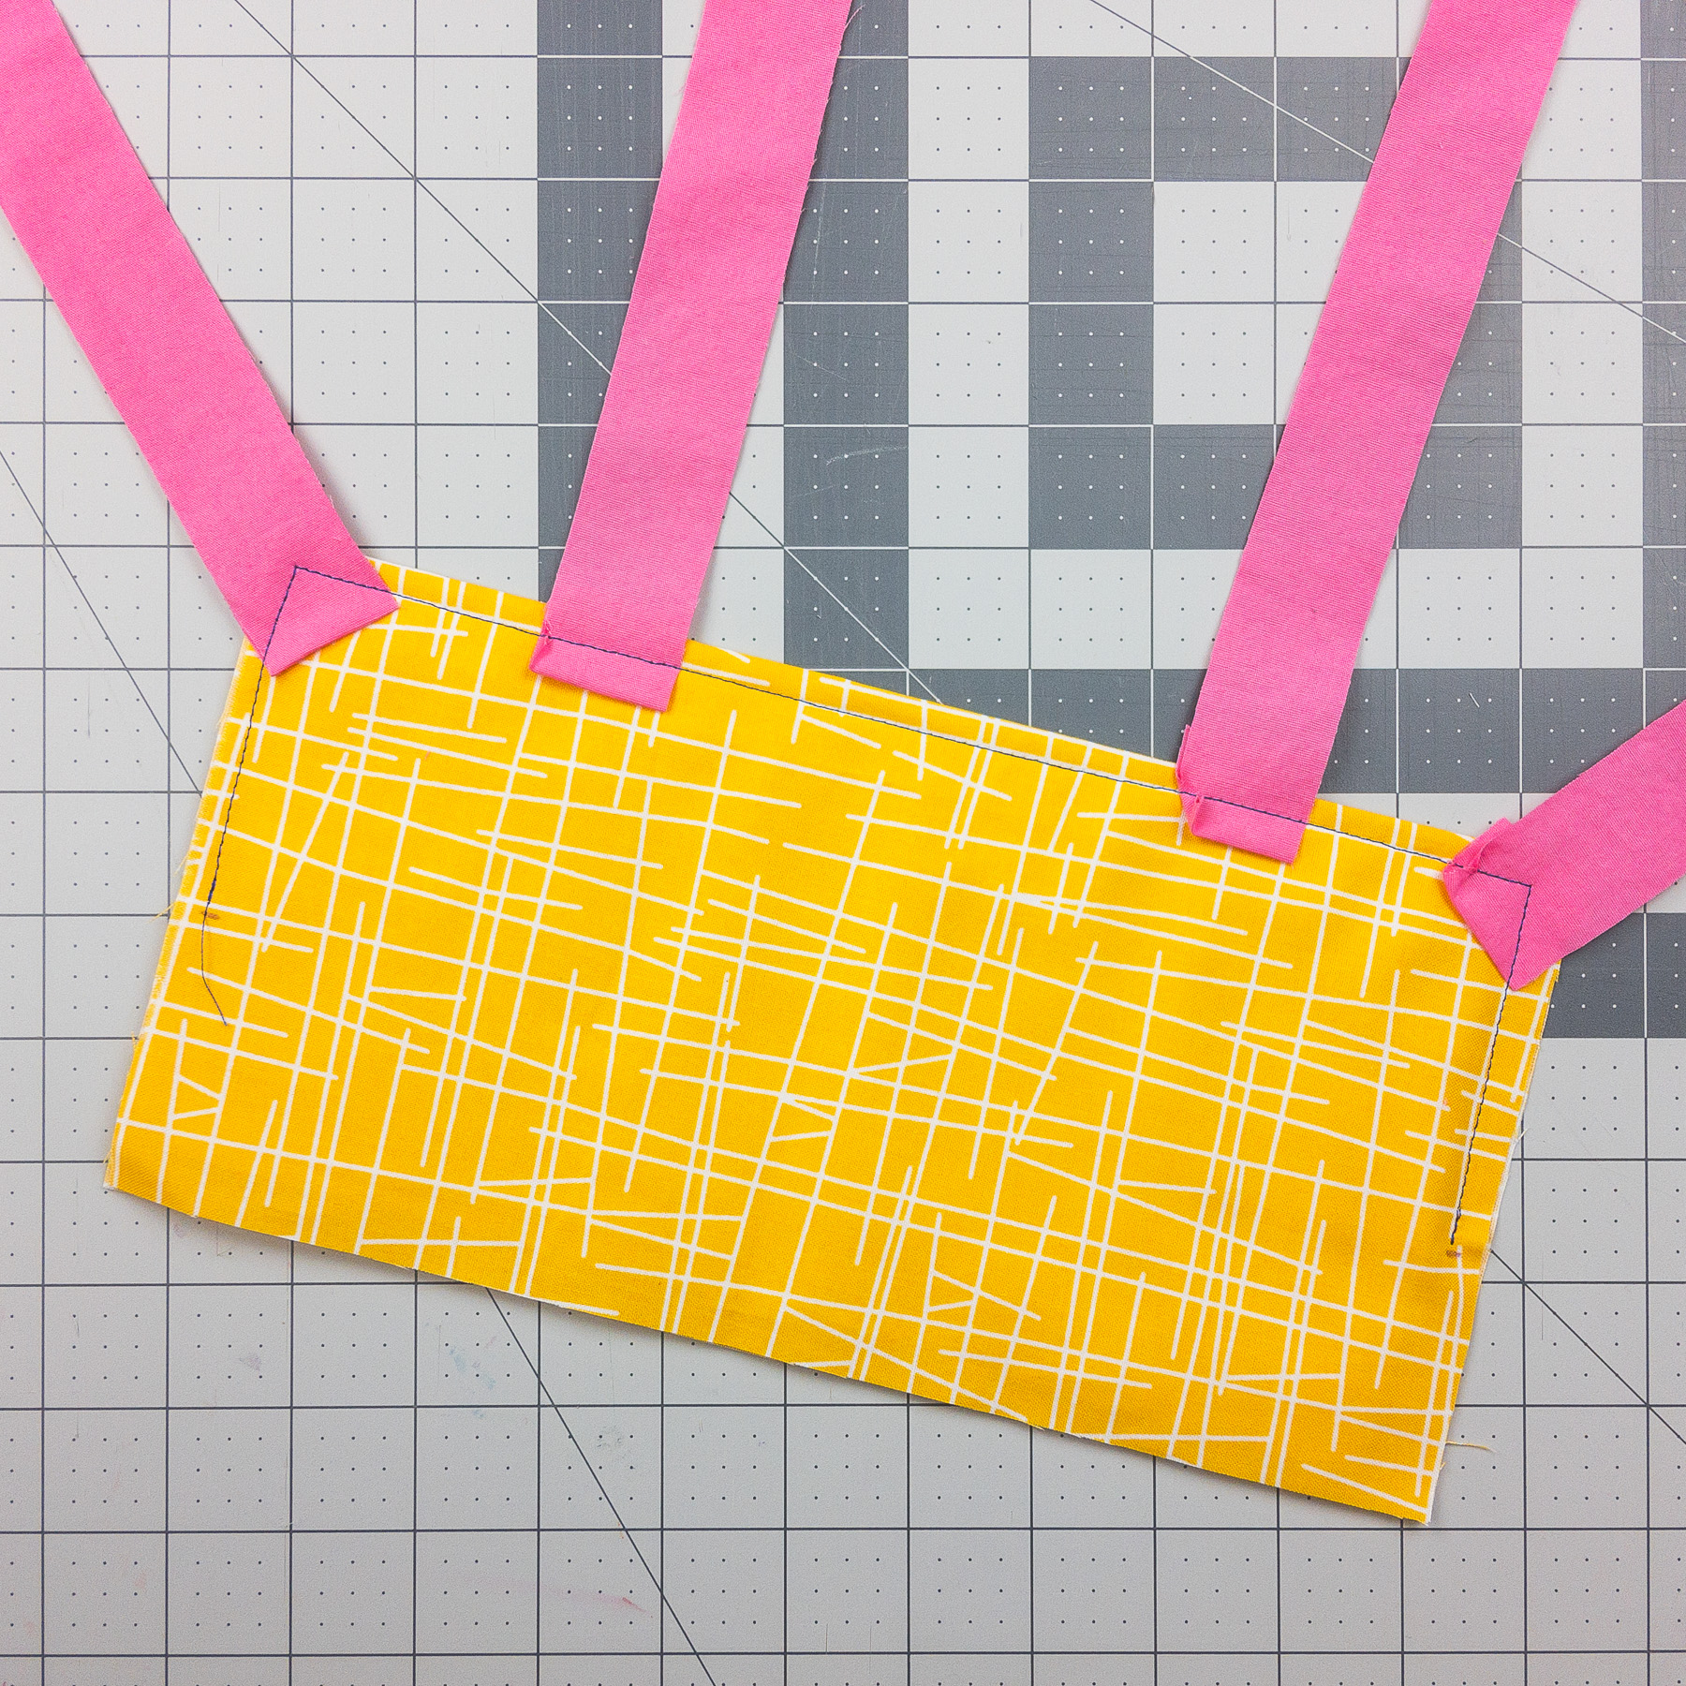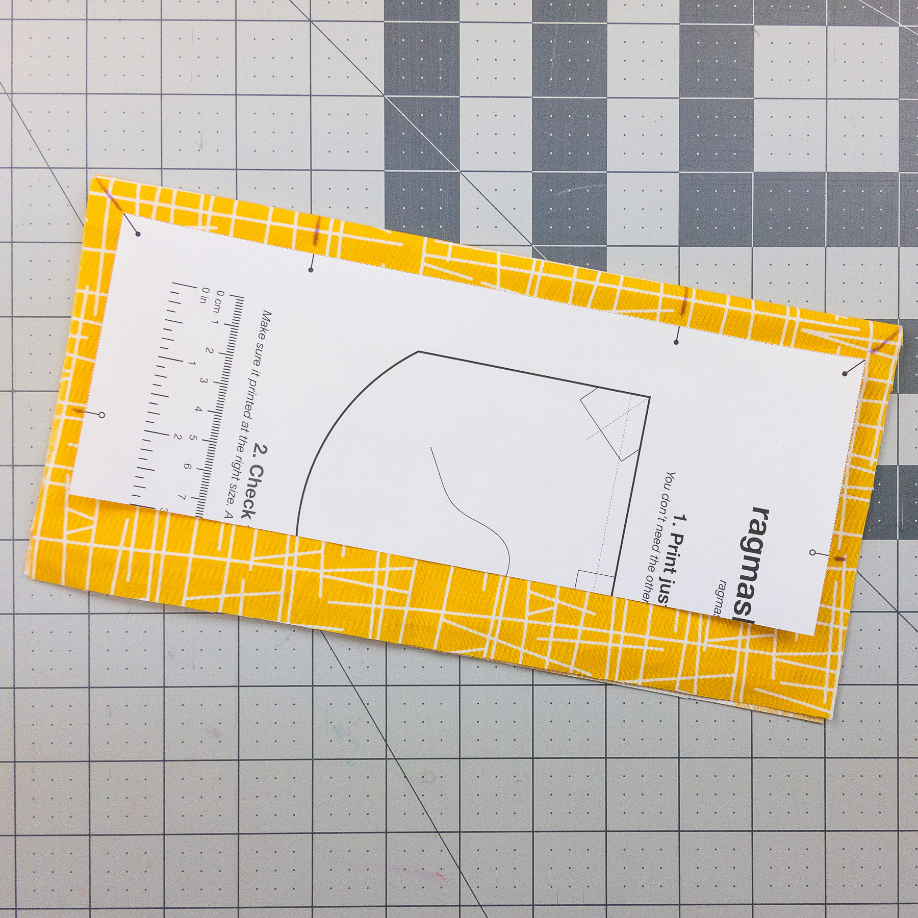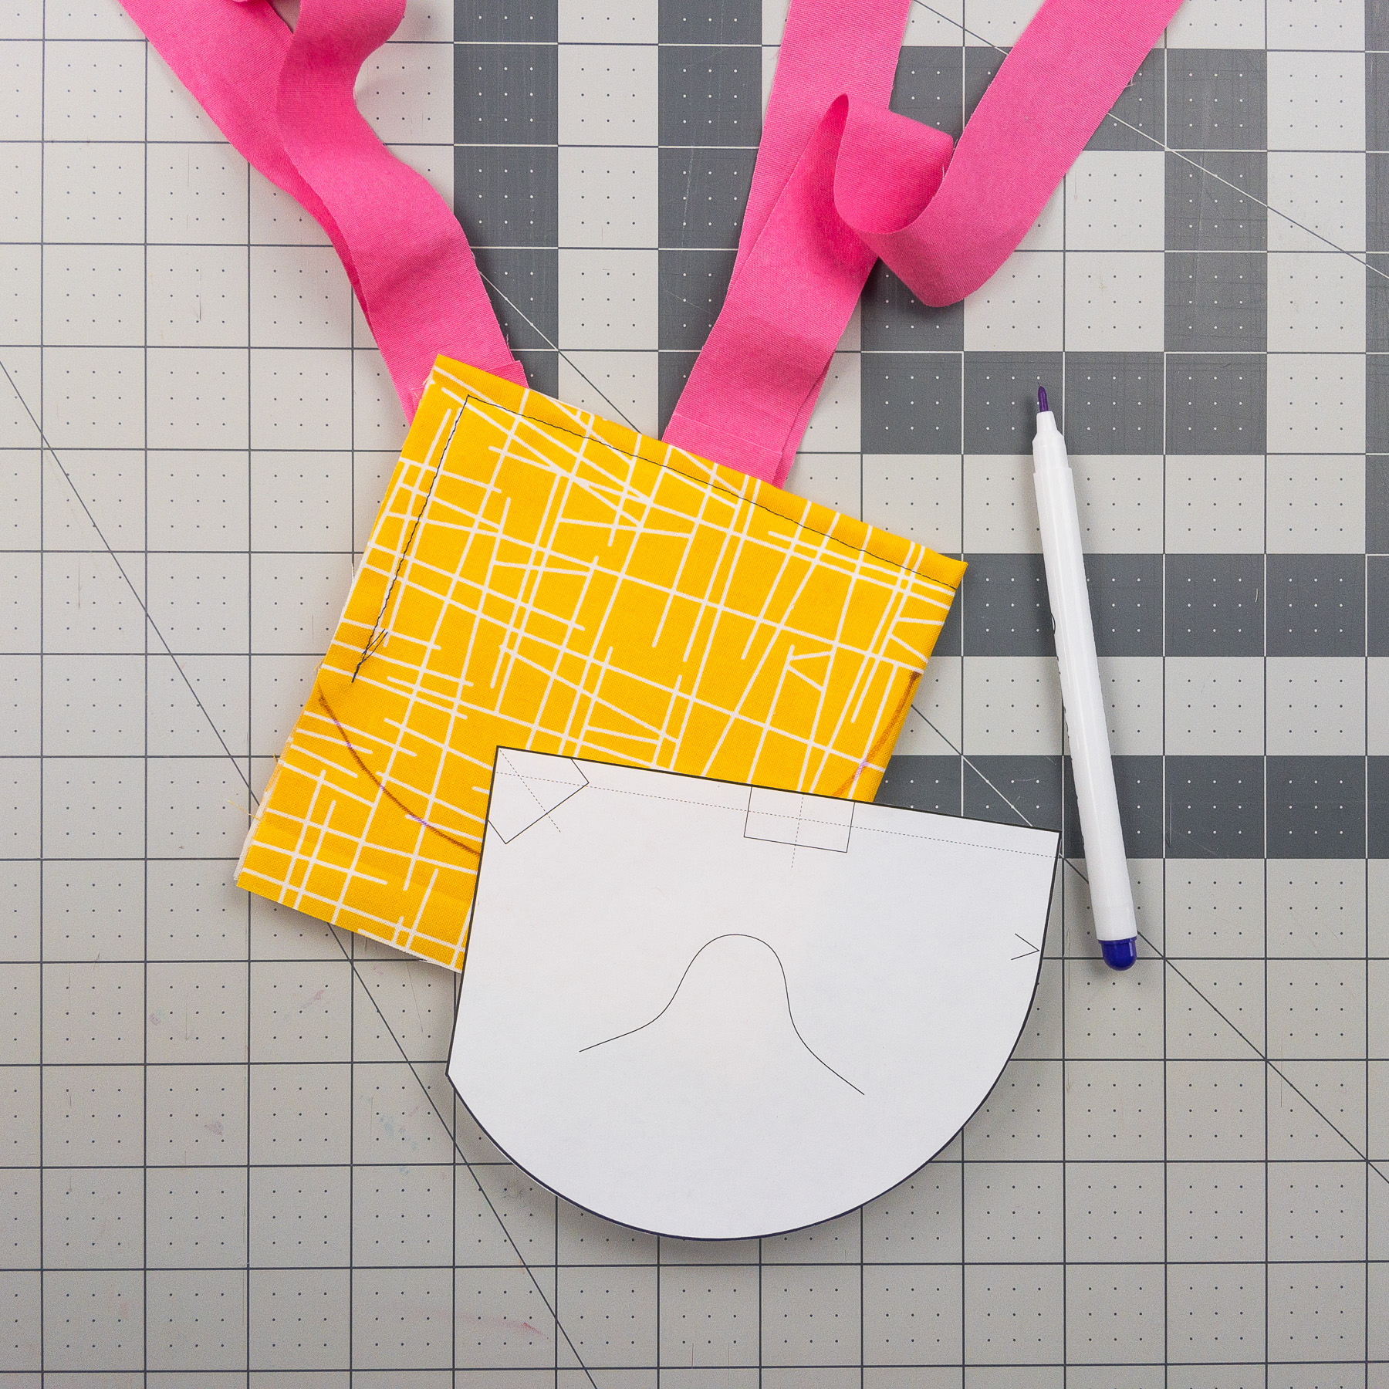

2. Sew straps on as part of the first stitch. (Backstitch over straps for added durability).

Pro Tip: Fast Straps

More tips at [ragmask.com/pro](http://ragmask.com/pro)

1. Print another copy of Page 1, trim template. After making first fold, mark centers of straps.

3. Fold in half (straps on the inside of the fold), mark, sew & cut as before.